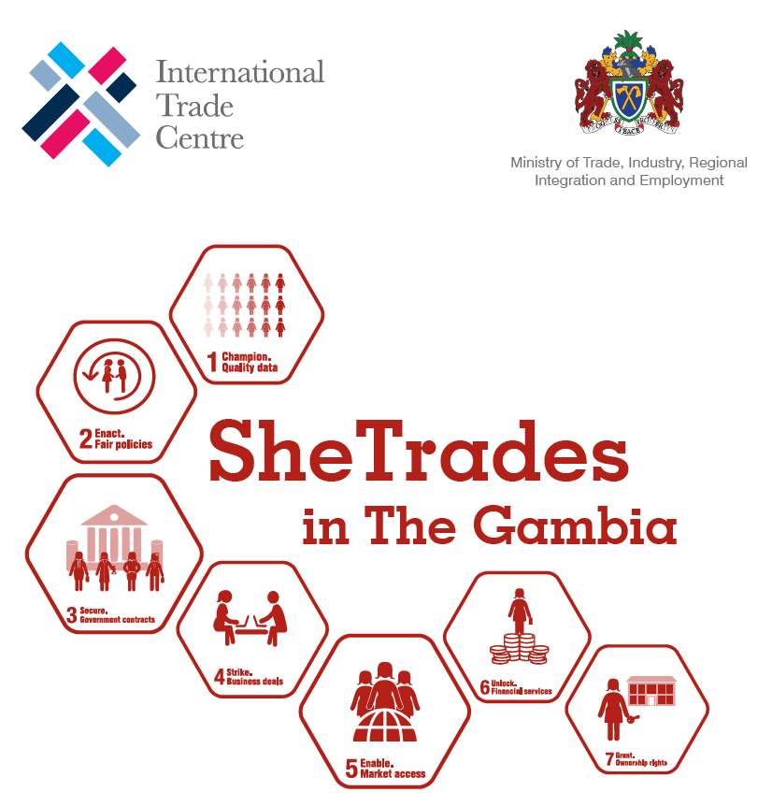**SHETRADES GRANT APPLICATION FORM AND BUSINESS PLAN TEMPLATE**

*This form should be electronically filled, printed, signed, and put in a sealed envelope with all the supporting documents clearly marked “Application for SheTrades Grants” and submitted to NACCUG or scanned and sent by email to minigrantschemegambia@gmail.com*

***Attention:*** *Alternatively, applications can be submitted to the following venues: NACCUG Head Office in Kanifing, Credit Union Shared Branching Offices located in GTUCCU Regional Offices in Brikama (next to Youth Centre), Soma, Basse and Farafenni, Foni Kansala Cooperative Credit Union (Bwiam), Sabunyima Cooperative Credit Union (Bansang), and Kerewan Fangdema Cooperative Credit Union (Kerewan NBR). Forms should be completed using clear legible hand writing in capital letter. The completed signed application with all the supporting documents can be submitted at the same credit union offices or may also be scanned and sent by email to* [*minigrantschemegambia@gmail.com*](mailto:minigrantschemegambia@gmail.com)

|  |  |  |  |  |  |  |  |  |  |  |  |  |  |  |  |  |  |
| --- | --- | --- | --- | --- | --- | --- | --- | --- | --- | --- | --- | --- | --- | --- | --- | --- | --- |
| 1. Date of Application | | |  | | | | | | | | | | | | | | |
|  | |  | | | | | | | | | | | | | | |
| 1. Name of Business | | |  | | | | | | | | | | | | | |
|  | |  | | | | | | | | | | | | | | |
| 1. Name of Owner | | |  | | | | | | | | | | | | | |
|  | |  | | | | | | | | | | | | | | |
| 1. Date of Birth | | |  | | | 1. ID Number | | | |  | | | | | | |
| 1. Name of Bank | | |  | | | 1. Account Type | | | | | | | | |  | Current |
| 1. Account Number | | |  | | |  | Savings |
|  | |  | | | | | | | | | | | | | | |
| 1. Name of Guarantor and Contact Details | | | |  | | | | | | | | | | | | |
|  | |  | | | | | | | | | | | | | | |
| 1. Business Address   (please specify if you are selling from home) | | | | | | 1. Region   ***Tick appropria-te region*** | | | |  |  |  |  |  |  |  |  |  |  |  | | --- | --- | --- | --- | --- | --- | --- | --- | --- | --- | --- | | GBA | WCR | LRR | CRR | NBR | URR |  | | CRR | NBR | URR | |  |  |  |  |  |  | |  |  |  |  | | | | | | | | | |
|  | | | | | |
|  | | | | | | | | | | |
| 1. Telephone No. | | | | | |  | | | | |
|  | | | | | | | | | | |
| 1. Email | | |  | | | | | | | |
|  | | |  | | | | | | | |
| 15. | 1. a. Number of employees in the business if any | | ***Full Time*** | |  | 1. Year of business registration & year of business establishment | | | | | | | ***Registration:*** | | | |
| ***Part Time*** | |  |
| b. How Many employees would you have in the business in the next 3 years? | |  | | | ***Establishment:*** | | | |
| 17. | | Please describe the core of your business and your business objectives (max. 3). What do you want to achieve? | | | | | | | | | | | | | | |
|  | |  | | | | | | | | | | | | | | |
| 18. | | Have you received any form of grants or financial assistance for your business in the past/present? If so please give details. | | | | | | | | | | | | | | |
|  | | | | | | | | | | | | | | |
| 19. | | Describe the features and benefits of the products or services you sell. | | | | | | | | | | | | | | |
|  | | | | | | | | | | | | | | |
| 20. | | What makes your business different? Why your products and services are unique compared to other competitors? | | | | | | | | | | | | | | |
|  | |  | | | | | | | | | | | | | | |
| 21. | | Summarize: why do you need the SheTrades Grant and how would this improve your business? (How will the grant increase the profitability/quality of your business? Do you plan to hire women? How does your business contribute to gender equality in The Gambia?) | | | | | | | | | | | | | | |
|  | |  | | | | | | | | | | | | | | |
| 22. | | How would you use the SheTrades Grant if provided? Please indicate by filling the table below | | | | | | | | | | | | | | |
| Description of Item  (incl. method of purchase & country) | | | | | | Unit Price (GMD) | | | | | Quantity | | | Total | | |
|  | | | | | |  | | | | |  | | |  | | |
|  | | | | | |  | | | | |  | | |  | | |
|  | | | | | |  | | | | |  | | |  | | |
|  | | | | | |  | | | | |  | | |  | | |
|  | | | | | |  | | | | |  | | |  | | |
|  | | | | | |  | | | | |  | | |  | | |
|  | | | | | |  | | | | |  | | |  | | |
|  | | | | | |  | | | | |  | | |  | | |
|  | | | | | |  | | | | |  | | |  | | |
|  | | | | | |  | | | | |  | | |  | | |
|  | | | | | |  | | | | |  | | |  | | |
|  | | | | | |  | | | | |  | | |  | | |
|  | | | | | |  | | | | |  | | |  | | |
|  | | | | | |  | | | | |  | | |  | | |
|  | | | | | |  | | | | |  | | |  | | |
|  | | | | | |  | | | | |  | | |  | | |
| 23. | | How much have you contributed to the operations of your business? | | | | | | | | | | | | | | |
|  | |  | | | | | | | | | | | | | | |
| 24. Previous expenses in year (12 months) before receiving SheTrades Grant (BREAK IT DOWN BY MONTH) | | | | | | | 25. Previous revenue in year (12 months) before receiving SheTrades Grant (BREAK IT DOWN BY MONTH) | | | | | | | | | |
|  | | | | | | |  | | | | | | | | | |
| 26. Expected expenses in first year (12 months) after receiving the SheTrades Grant (BREAK IT DOWN BY MONTH) | | | | | | | 27. Expected revenue in first year (12 months) after receiving the SheTrades Grant (BREAK IT DOWN BY MONTH) | | | | | | | | | |
|  | | | | | | |  | | | | | | | | | |
| 28. | | Please specify in what ways the SheTrades Grant will help your business to become more sustainable. | | | | | | | | | | | | | | |
|  | |  | | | | | | | | | | | | | | |
| 29. | | Documents to be attached by the applicant   * Business Registration (if any) * National Identification (ID, Passport, Driving License) * Business/TVET Training Certificate * Statement of Accounts (if any) | | | | | | | | | | | | | | |
| 30. | | **Declarations**  **a. Applicant**  I declare that to the best of my knowledge, all information provided in this application is correct and complete. I am aware that any false information may lead to my application being rejected.  **b. Guarantor**  I confirm that the information contained in the application and the accompanying documents are correct and complete. As the Guarantor to this applicant, I understand that if the grant is not used for the purpose for which it was approved, I will be responsible for refunding the full amount. | | | | | | | | | | | | | | |
| **Applicant’s Signature** | | | | | |  | | **Guarantor’s Signature** | | | | | | | | |
| **Date:** | | | | | |  | | **Date:** | | | | | | | | |

**APPENDIX A: ELIGIBILITY CRITERIA TO ACCESS SHETRADES GRANT**

1. Beneficiaries must be part of the SheTrades Gambia cohort I or II and fulfill the SheTrades requirements (at least 30% owned, managed and controlled by woma(e)n, residing in The Gambia, active in horticulture and/ or textiles & garments industries).

For more information on how to become a SheTrades Gambia company, visit: <https://www.shetrades.com/en/projects/shetrades-gambia>

1. Should have some level of savings or commit to making regular savings in a financial service provider of his or her choice.
2. Must provide a business plan using this application template.
3. Agree to maintain in a professional manner the record of the business and be open to be monitored.
4. Must provide a guarantor before disbursement to indicate that the grant will be used for the intended purpose. Failure of doing so implies that the amount of the grant will be refunded in full by the guarantor.
5. Beneficiaries must have regularly attended trainings by SheTrades Gambia and will actively continue to attend them when required by SheTrades Gambia.
6. Activities of the business must not be illegal or detrimental to the environment.
7. Business plans that show a high level of innovation and determination will be an advantage.
8. The Grant Coordinating Committee reserves the right to approve or not to approve any proposal received.
9. The maximum eligible amount is GMD 250, 000 which will only be disbursed in case of outstanding applications and thorough reasoning.
10. Beneficiaries receiving a SheTrades Grant are not eligible for to apply for the Tekki Fii Agro-Grant or Solar-Grant. Beneficiaries who have already received such a Tekki Fii grant cannot receive the SheTrades Grant.

**APPENDIX B: ELIGIBILITY CRITERIA TO SERVE AS A GURANTOR**

1. He/she must be a Gambian
2. He/she must provide a valid Gambian identification document
3. He/she must not be less than 25 years of age
4. He/she must be willing to serve as adviser to the beneficiary
5. He/she must be willing to accept to serve as guarantor to beneficiary and hereby agree to refund to the full grant amount in the event that the beneficiaries misuse/mismanage the grant plus any damages relating to the recovery of the amount.